OS Lab Assignment - 14

**Submitted By -: Rohan Kumar**

**Section -: C**

**Roll No. -: 52**

**Subject -: Operating System Lab (BCSC 0803)**

**Submitted To -: Ms. Nidhi**

Ques – Write a shell script to read numbers from three subject and calculate the grade the accordingly..

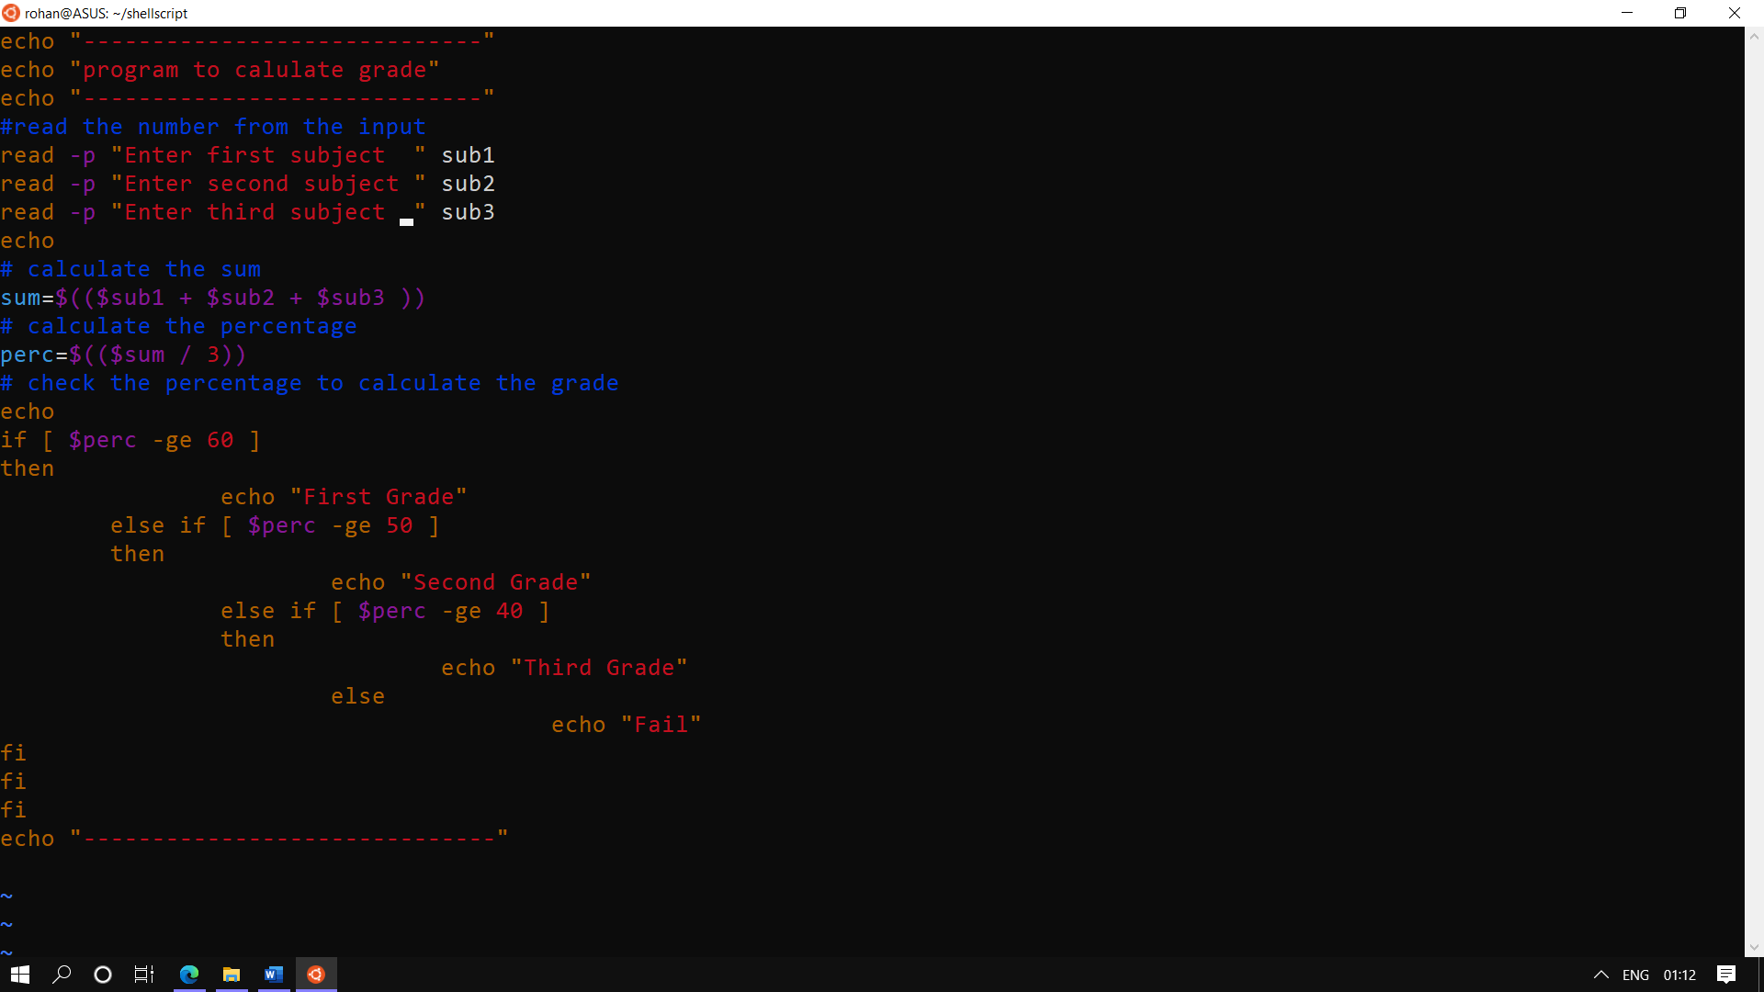

The output:--

